1. Uploading a file from Hadoop to HDFS using ‘Put’ command without specifying a target directory

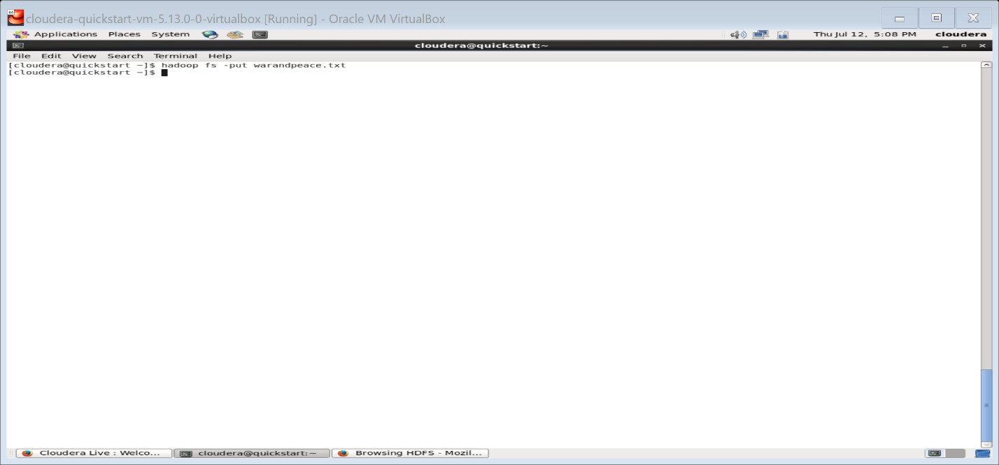

Validating if the file got sent to hdfs file system using browser

1. Open a browser by clicking the highlighted icon

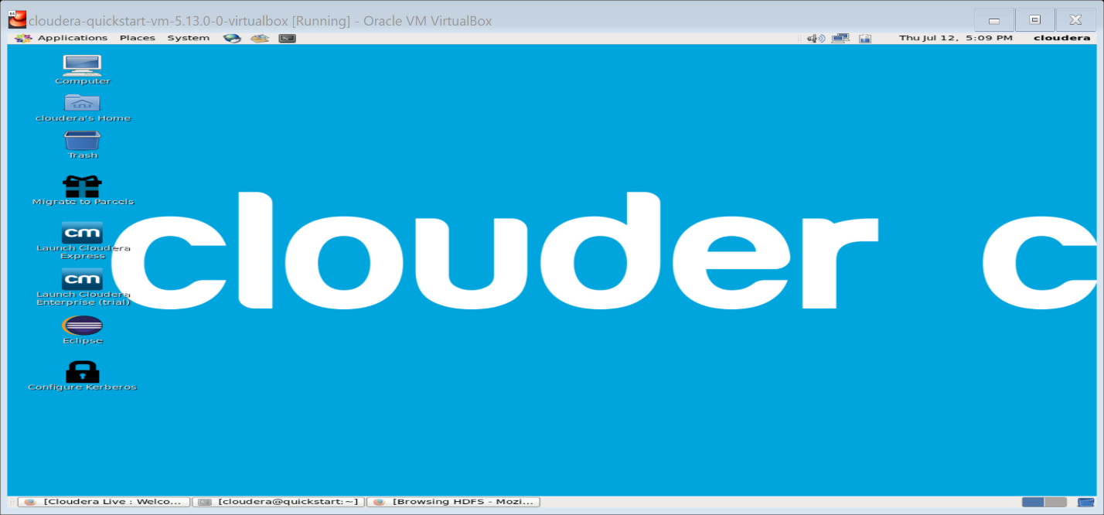

1. In the browser, navigate by clicking the Hadoop tab on the ribbon below the address bar and click ‘HDFS NameNode’

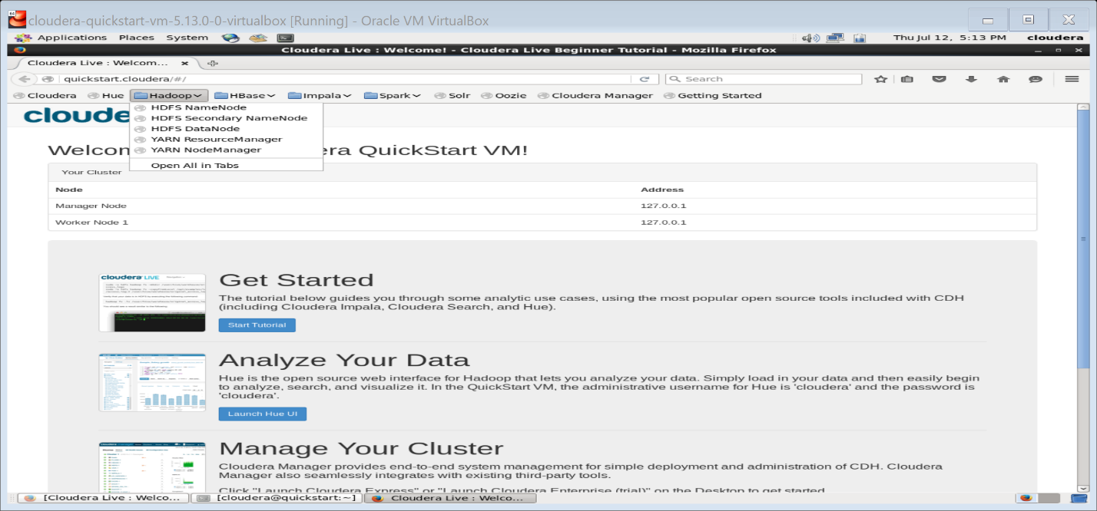

1. A new page opens with NameNode details as follows, click Utilities dropdown and click ‘Browse the file system’ as shown below

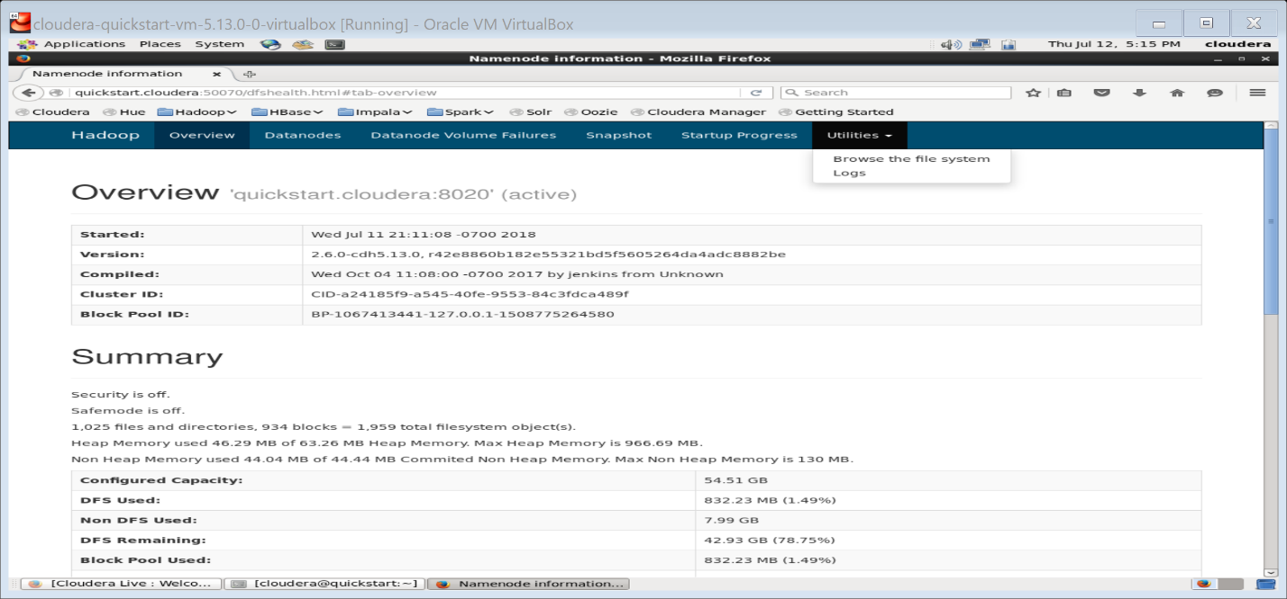

1. The following directory structure is displayed

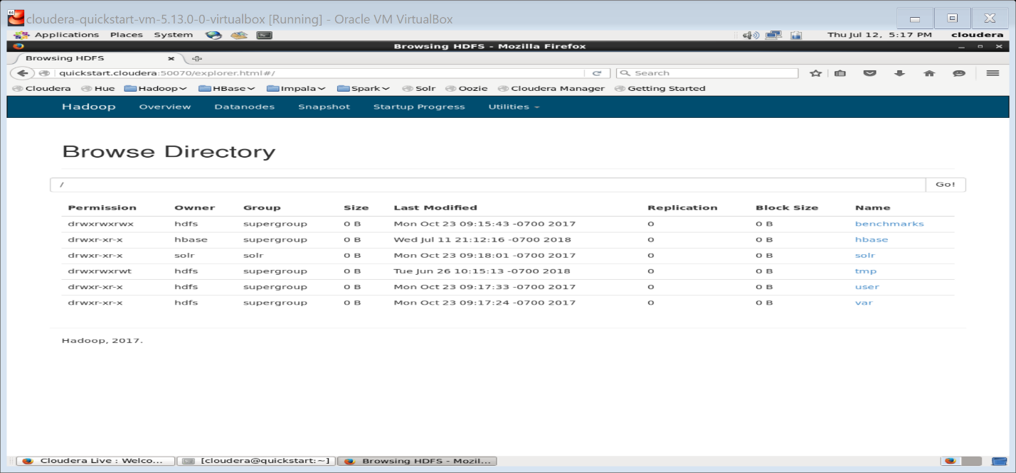

1. Click on ‘user’ directory and the following directories under ‘User’ folder is displayed. Click on the directory ‘cloudera’

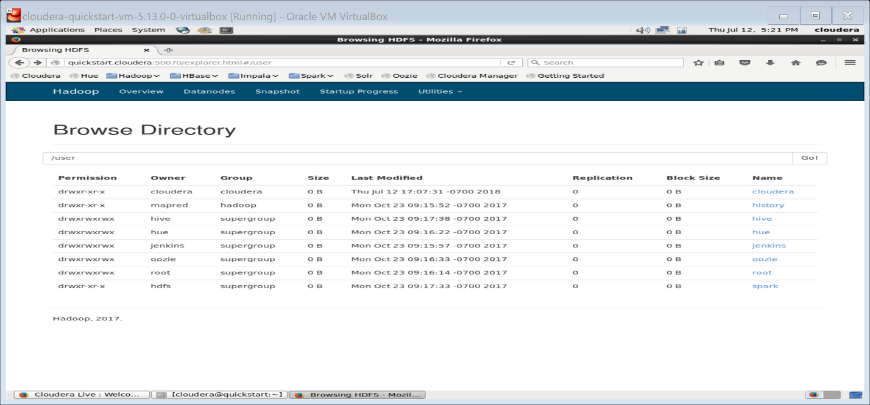

1. On clicking ‘cloudera’ directory, we could see that the file that we had tried to send to HDFS through put command is saved here.

